Lab Report

Your Information
Your Name: Josh Zimmerman-Gibson
Assignment Title: SQL Database Creation and Querying

Screenshots
Step 1.2: Creating Tables
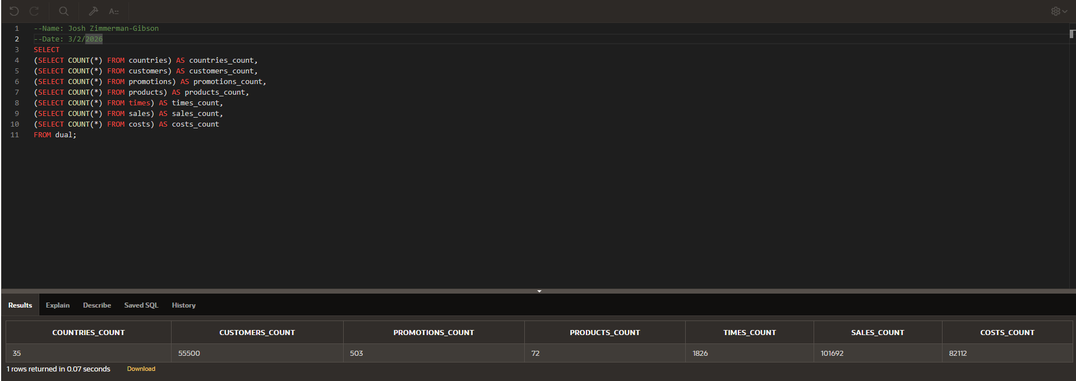
Step 2.1: Retrieve All Data
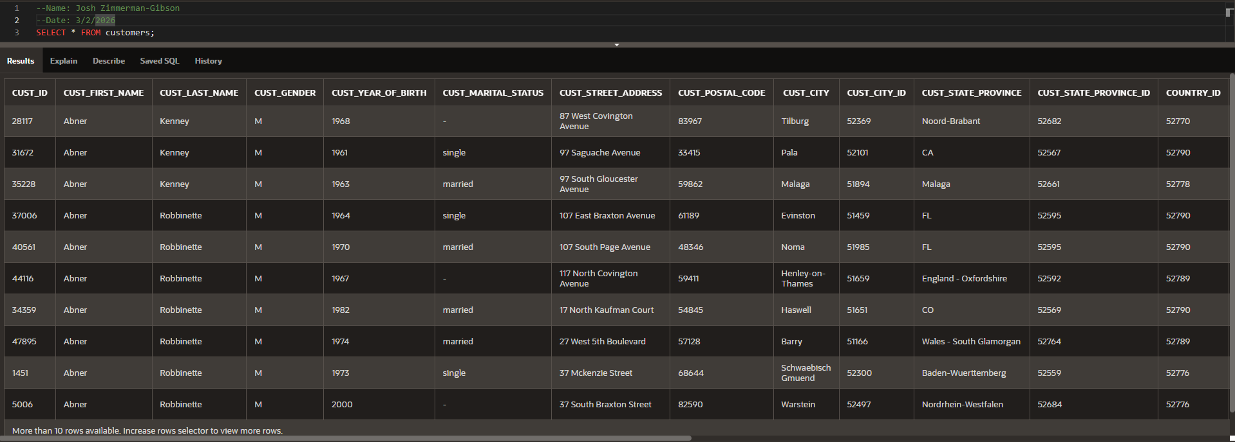
Step 2.2: Filter Data by Gender
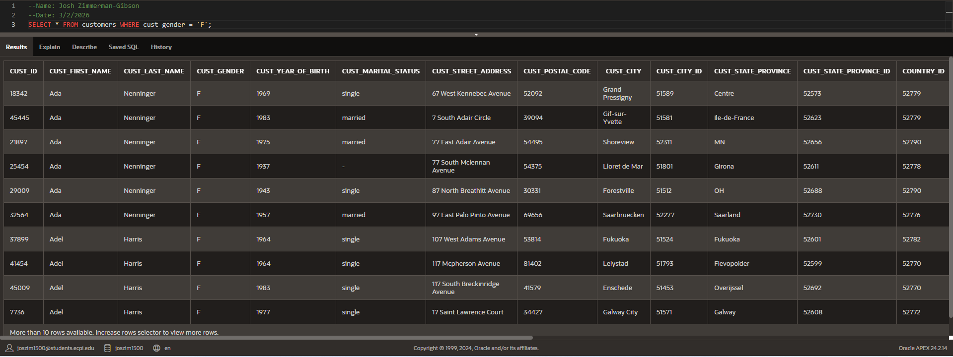
Step 2.3: Filter Data by Age
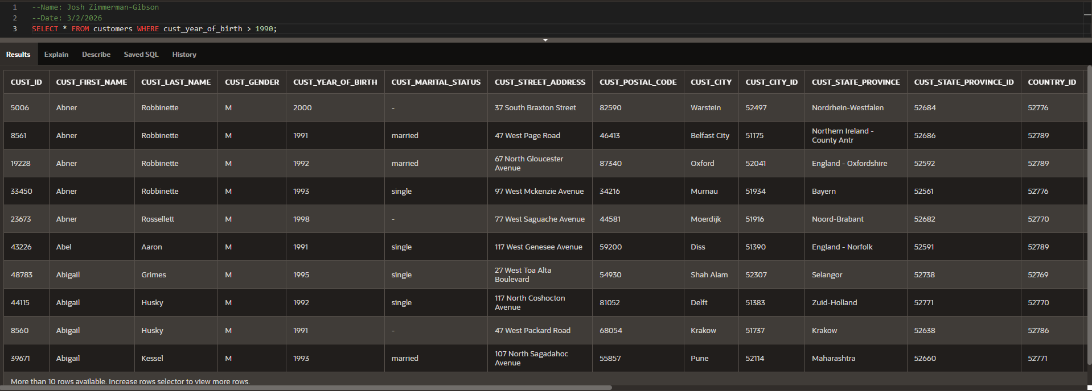
Step 2.4: Combine Multiple Filters
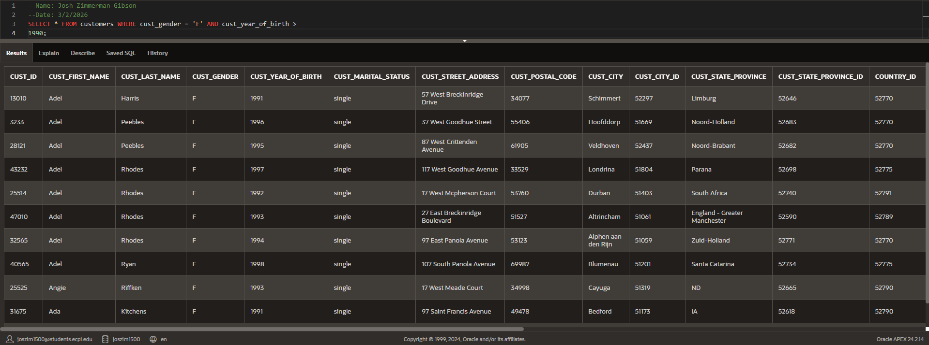
Step 2.5: Explore Product Categories
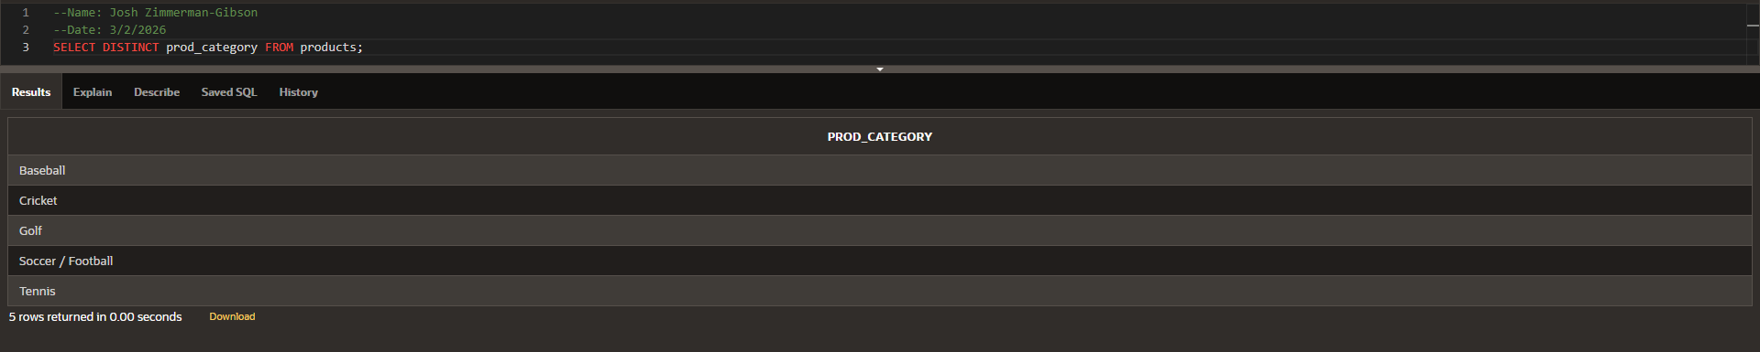
Step 2.6: Order Customers by Last Name
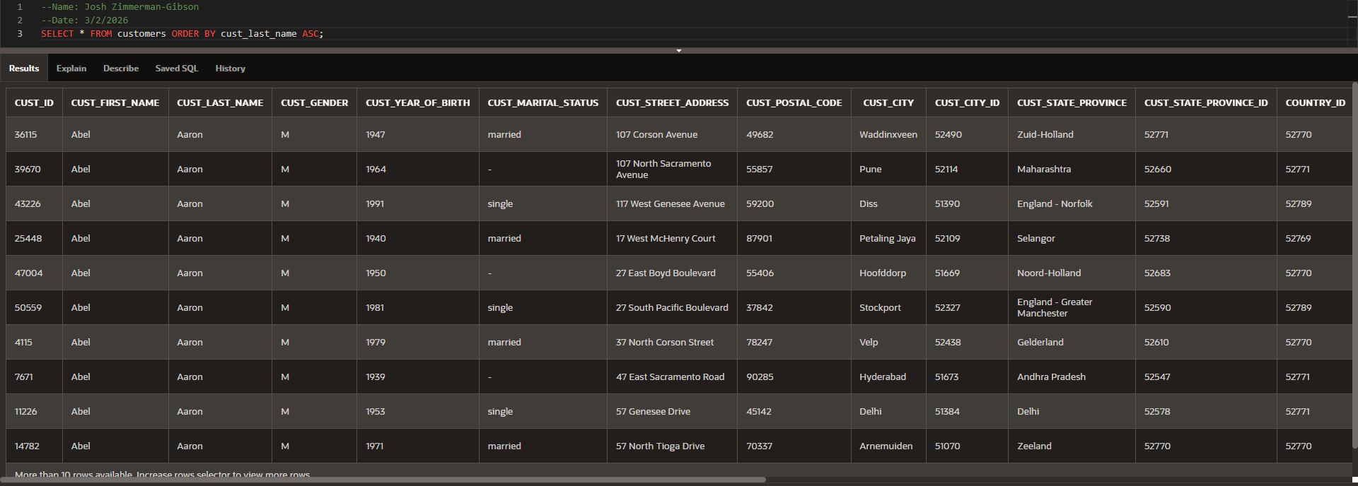
Step 2.7: Order Promotions by Cost
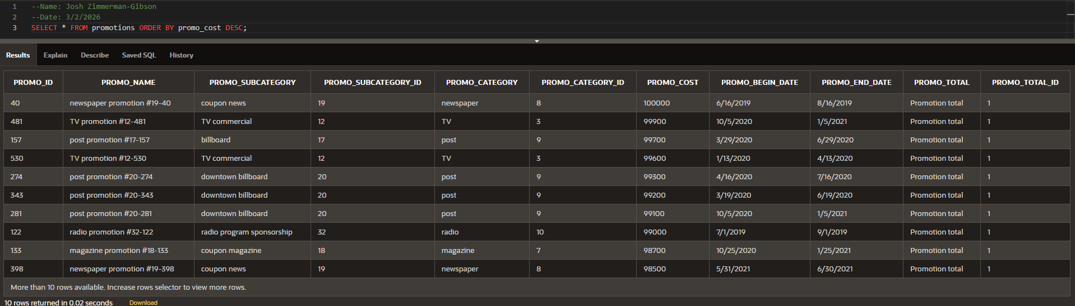
Step 3.1: Calculate Total Sales by Promotion
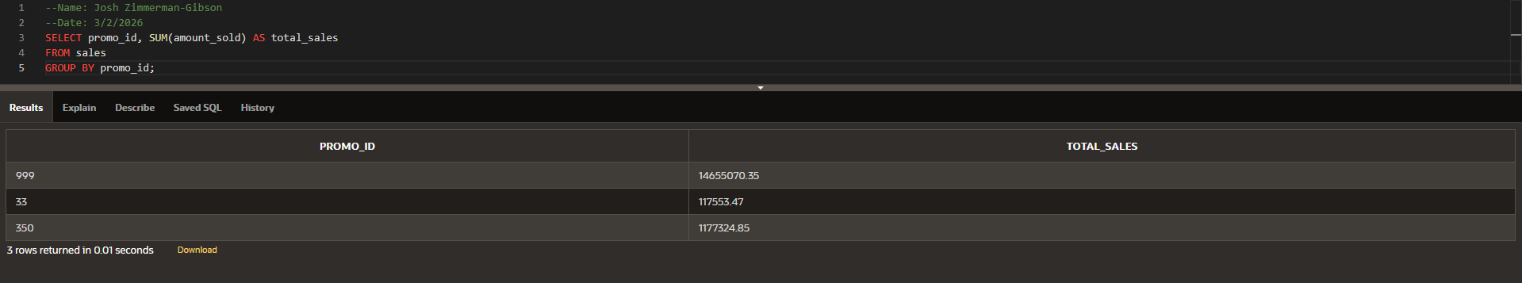
Step 3.2: Find Total Amount Sold per Customer
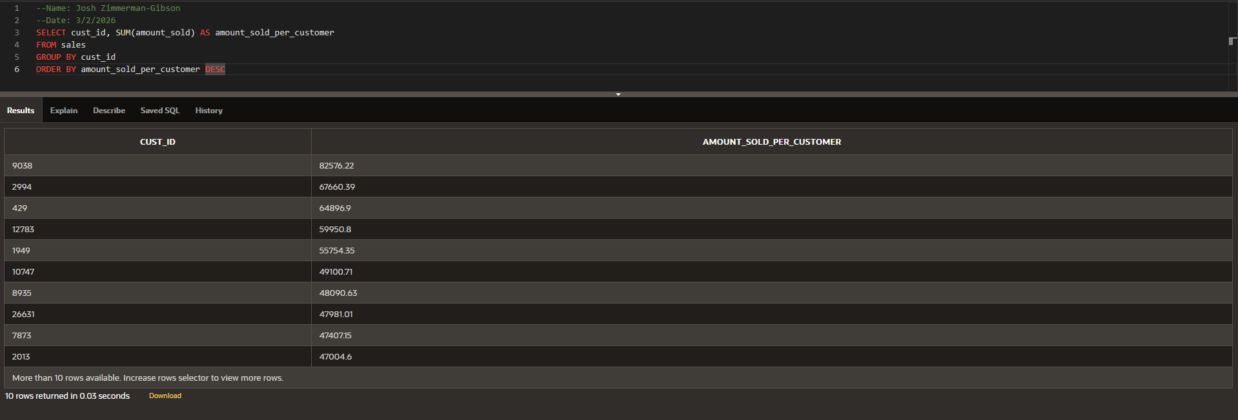
Step 3.3: Identify High-Value Customers
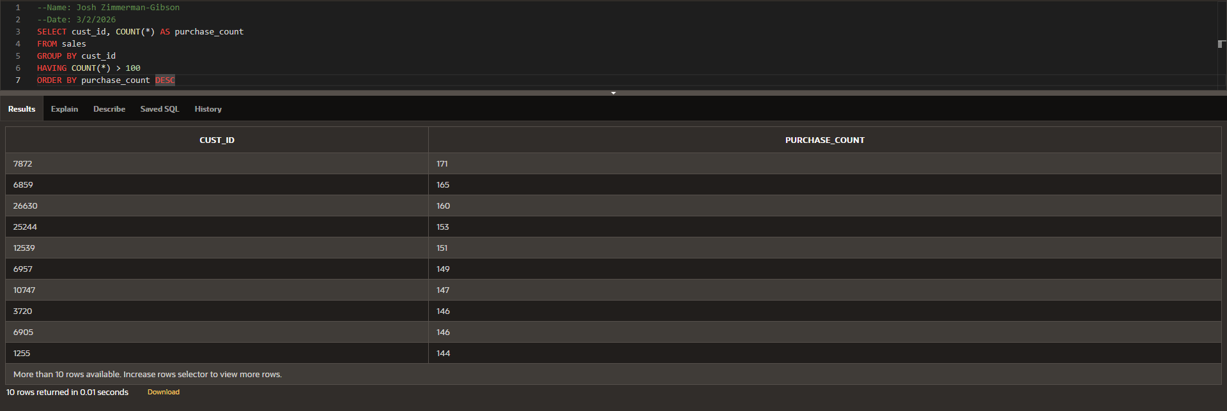
Step 3.4: Find Products with High Sales Count
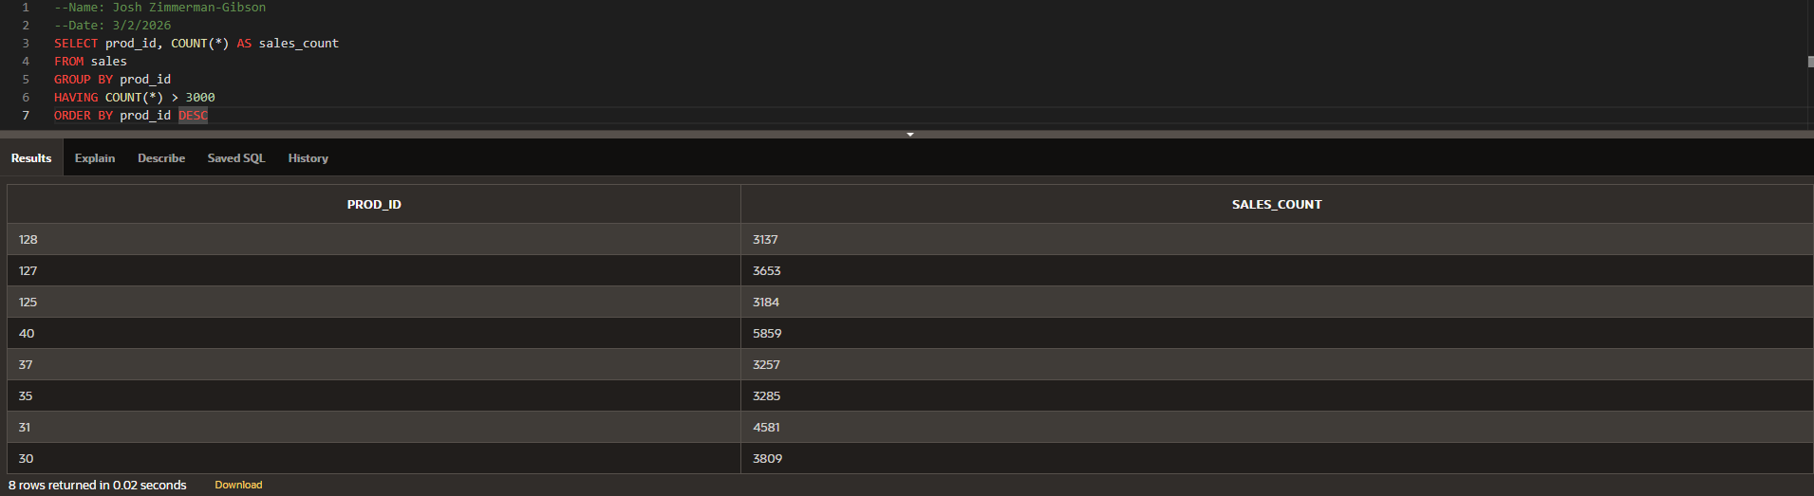
Step 4.1: Perform a Two-Table Join
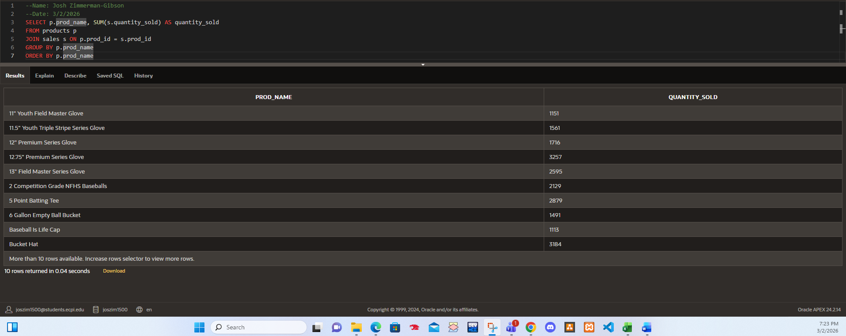
Step 4.2: Perform a Three-Table Join
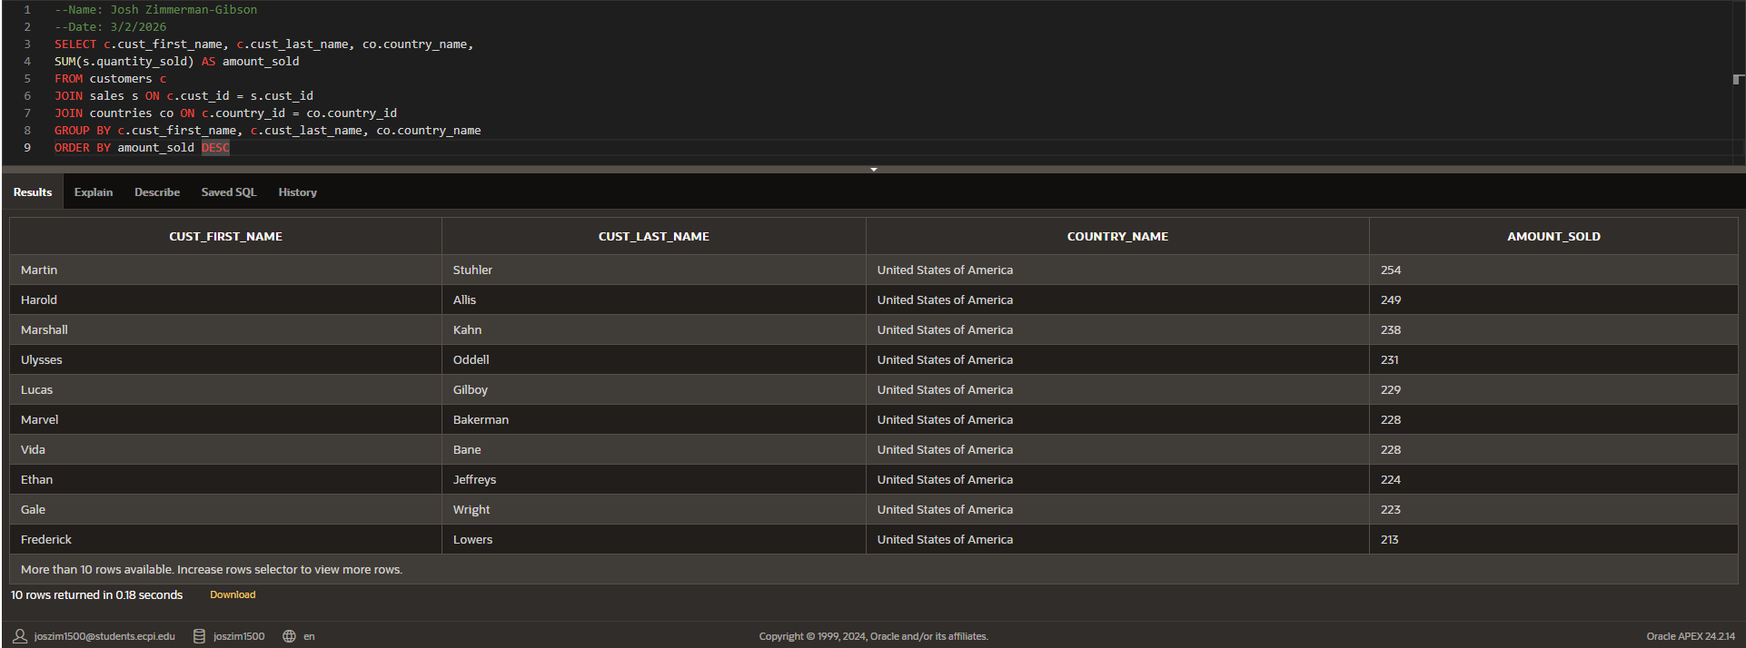
Step 4.3: Perform a Four-Table Join
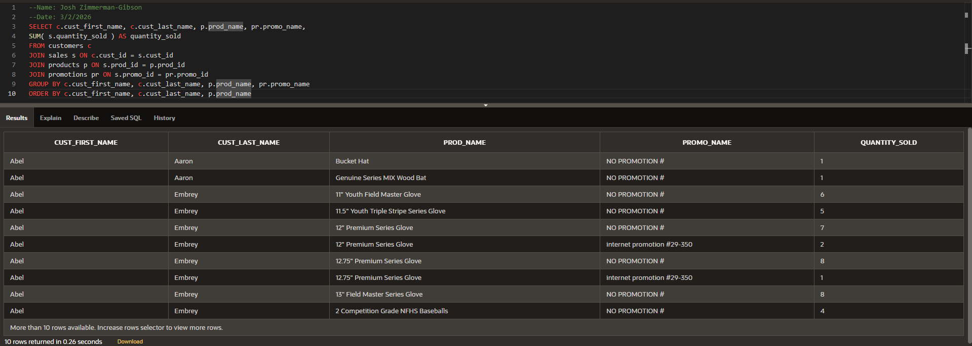
Step 4.4: Calculate Total Sales Amount by Country
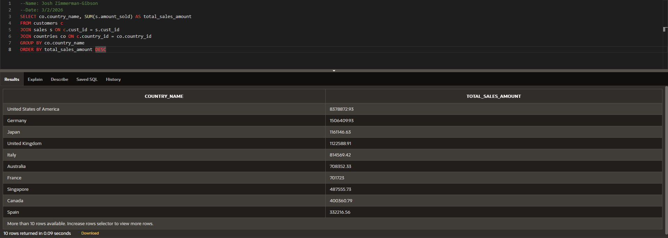
Step 5.1: Promotion Effectiveness
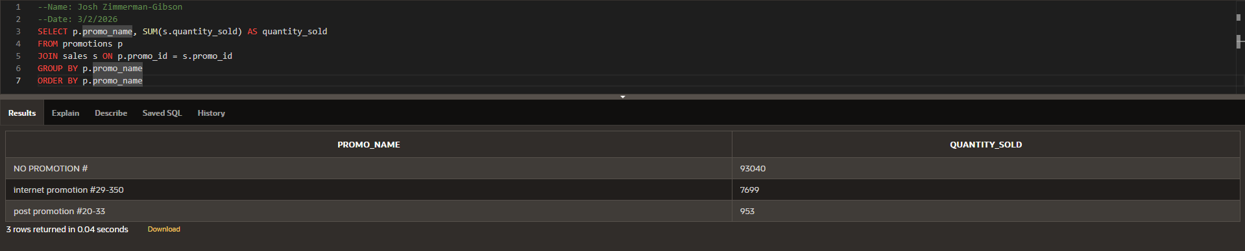
Step 5.2: Monthly Sales Trend
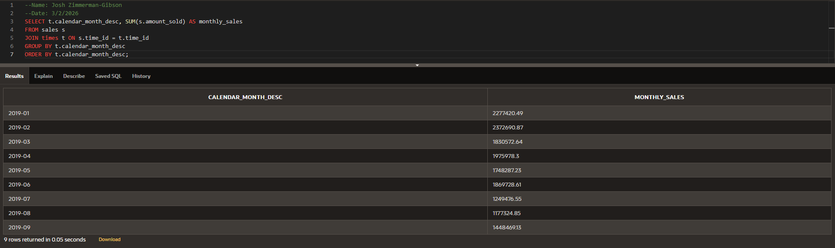
Step 5.3: Customer Purchasing Behavior
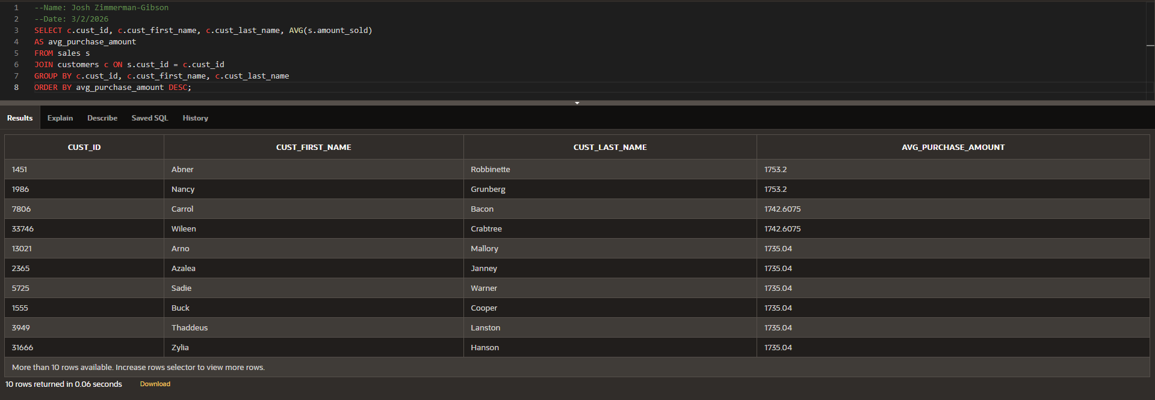
Step 5.4: Channel Performance Comparison
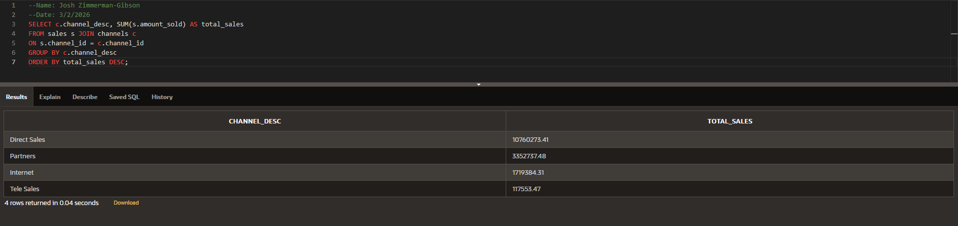
Step 6.1: Weekly Sales by Product Subcategory
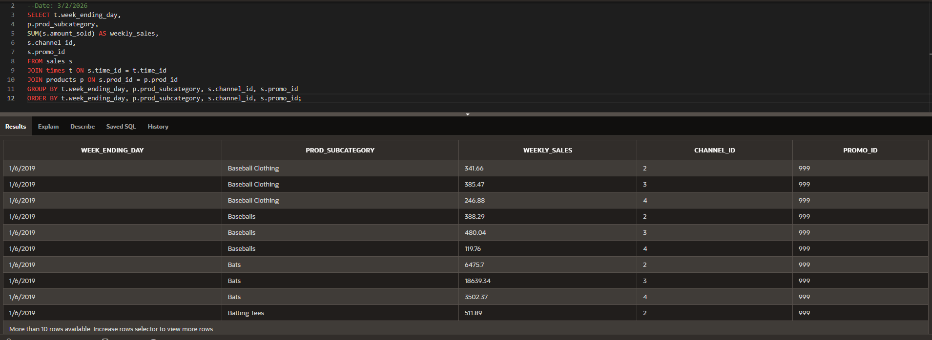
Step 6.2: Weekly Sales by Channel
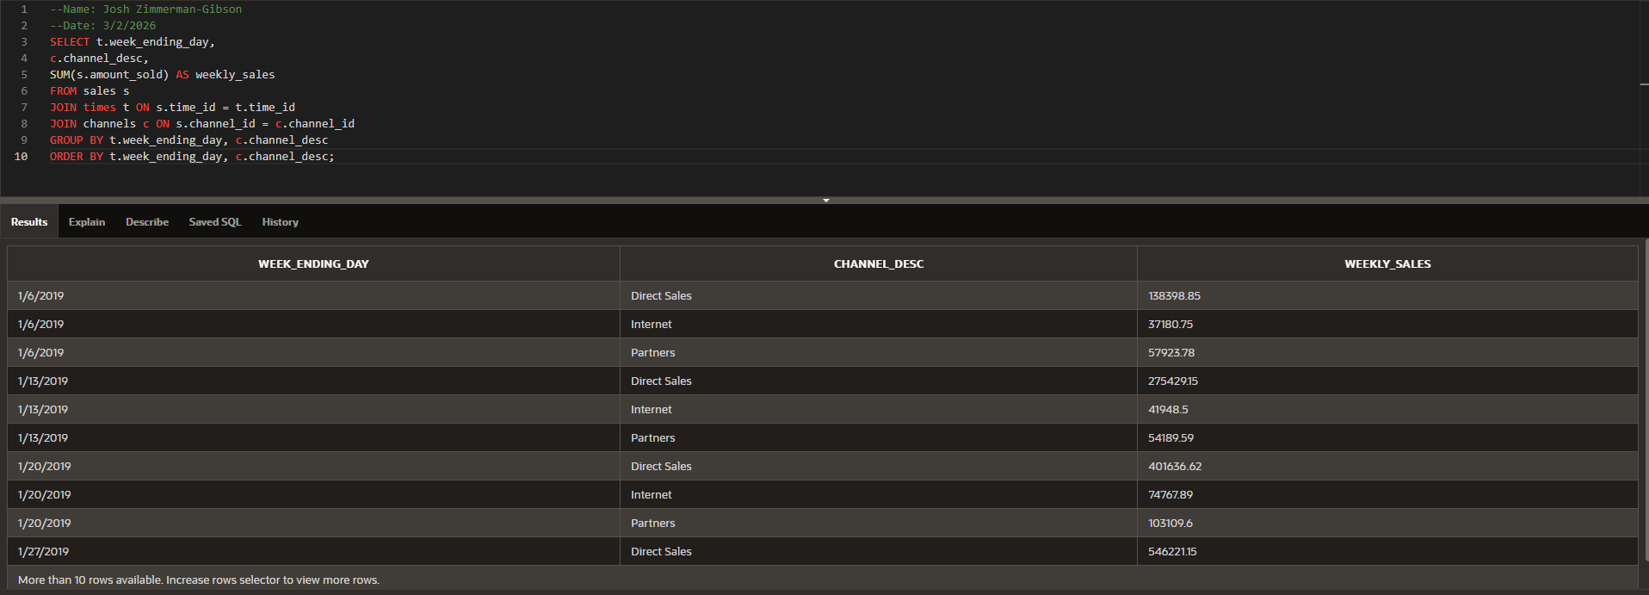
Step 6.3: Weekly Sales by Product Subcategory and Channel
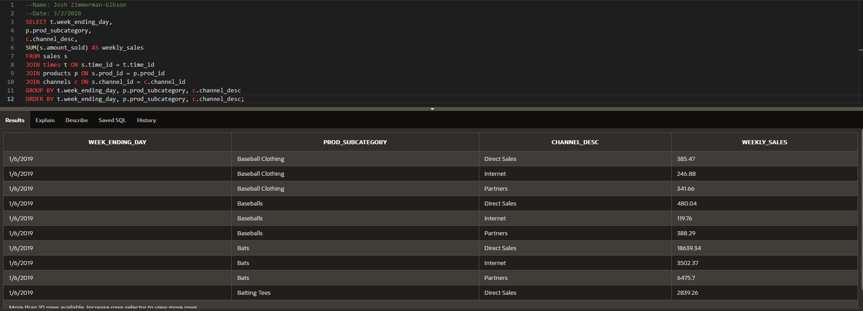

Questions
1. In the guided practice, we covered various SQL tasks, including basic data selection, filtering,
aggregation, and complex queries. Please explain the key differences between these types of
SQL queries and when you would use each of them in a data analytics project.
Basic data selection (primarily SELECT with optional WHERE, ORDER BY, LIMIT): This is the foundation of SQL querying. It retrieves raw or lightly filtered rows from one table. Use it during initial data exploration (EDA), when you need to quickly view records, check data quality, or pull a sample of data (e.g., "show me the first 100 customers").
Filtering (using WHERE, AND/OR, comparison operators, LIKE, IN, BETWEEN, etc.): Narrows down rows based on conditions. Use it when you need to focus on a specific subset of data (e.g., "only female customers over age 35" or "sales in the last 90 days"). Filtering is essential for targeted analysis and reduces the dataset size early.
Aggregation (using GROUP BY + aggregate functions like COUNT, SUM, AVG, MIN, MAX): Summarizes data across groups rather than showing individual rows. Use it when the goal is to compute totals, averages, or counts at a higher level (e.g., "total sales by promotion", "average order value by country", "number of customers per age group"). Aggregation turns raw data into business metrics.
Complex queries (combining multiple elements: joins, subqueries, CTEs, window functions, multiple GROUP BY levels, HAVING, etc.): These integrate several operations to answer multi-dimensional business questions. Use them when simple queries are insufficient, e.g., ranking customers by lifetime value while joining sales, customer, and geography tables, or calculating year-over-year growth with window functions. They are common in dashboards, executive reports, and advanced analytics.
2. One of the tasks involved joining multiple tables to retrieve specific data. Please provide an
example of a real-world scenario where joining tables from a relational database would be
essential for conducting meaningful data analysis. What types of insights can be gained from
such joins?
Real-world example: An e-commerce company wants to understand which marketing channels are most effective at acquiring high value repeat customers.
Relevant tables might include:
- customers (customer_id, name, signup_date, country, lifetime_value)
- orders (order_id, customer_id, order_date, total_amount, channel_id)
- marketing_channels (channel_id, channel_name, cost_per_acquisition)
- products (product_id, order_id, product_category, quantity)
A four-table join (similar to Step 4.3 in the lab) would be essential to connect customer demographics, purchase behavior, acquisition channel, and product details in one query.
Insights gained from such joins:
- Which acquisition channels (e.g., Google Ads vs. Instagram vs. email) produce customers with the highest average lifetime value and repeat purchase rate.
- Whether certain channels drive sales of high-margin product categories.
- Geographic differences in channel performance (e.g., Facebook performs better in urban vs. rural areas).
- Cost-effectiveness: channel ROI = (total revenue from customers acquired via channel) / (total acquisition cost).
- Customer segmentation: identify "high-value channel loyalists" for targeted retention campaigns.
Without joins, analysis would be limited to single-table views (e.g., only orders or only customers), missing the relationships needed for actionable business decisions.

3. In the final task of the guided practice, we conducted a comprehensive data analytics project
using SQL. Please describe the steps you would take when approaching a similar project in a
real work environment. How would you ensure data accuracy, handle complex queries, and
present your findings effectively?
Steps in a real work environment:
- Business & stakeholder alignment — Meet with stakeholders to clearly define the business question(s), success metrics, and required output (dashboard, report, one-time analysis, etc.).
- Data discovery & understanding — Explore database schema (tables, columns, keys, relationships), check data dictionaries, and run basic profiling queries (SELECT COUNT(*), COUNT(DISTINCT ...), MIN/MAX dates, check for NULLs/duplicates).
- Data preparation & cleaning — Write queries to identify & handle missing values, inconsistent formats, invalid dates, duplicates. Create views or temporary tables for cleaned/transformed data if needed.
- Iterative query development — Start simple (basic selects/filters), gradually add joins, aggregations, CTEs/window functions. Test each layer on small data subsets. Use meaningful aliases and comments in code.
- Validation & quality checks — Cross-check totals against known values (e.g., grand total sales should match finance reports). Compare SQL results with exported samples in Excel/Python. Use sanity checks (e.g., no negative quantities, dates in reasonable range).
- Performance optimization — If queries are slow on large tables, add indexes (if permitted), limit date ranges, use appropriate join order, or move complex logic to materialized views/CTEs.
- Documentation — Save final queries in version control (e.g., Git), document assumptions, limitations, and definitions of key metrics.
- Presentation of findings — Choose the right format:
  - Dashboard (Tableau, Power BI, Looker): interactive filters, visuals (bar charts for trends, heatmaps for crosstab analysis).
  - Report/PDF: executive summary, key insights, supporting visuals, methodology appendix.
  - Meeting: walk through 3–5 main takeaways, use simple charts/tables, explain "so what" implications.
  - Include confidence notes (e.g., "based on last 24 months of data", "excludes refunds processed after cutoff").
Ensuring data accuracy — Multiple validation layers (row counts, totals reconciliation, sample checks, peer review if possible).
Handling complex queries — Break into CTEs, use descriptive aliases, test incrementally, comment liberally.
Effective presentation — Focus on business impact over technical details; use visuals over large tables; tell a clear story (problem → analysis → insight → recommendation).

